Department Activities (2022-23)
- Organized Student Induction and Orientation Program on 10-8-2022.

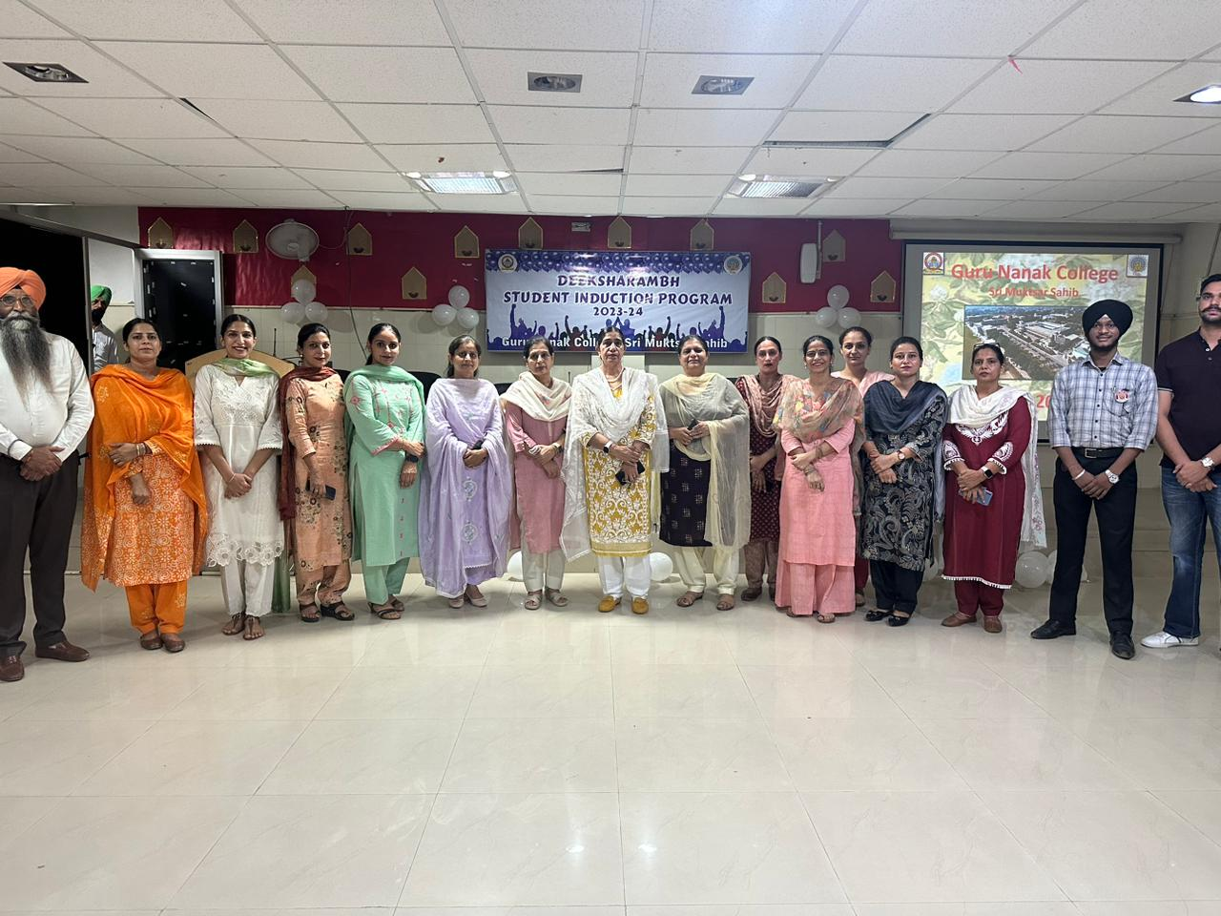

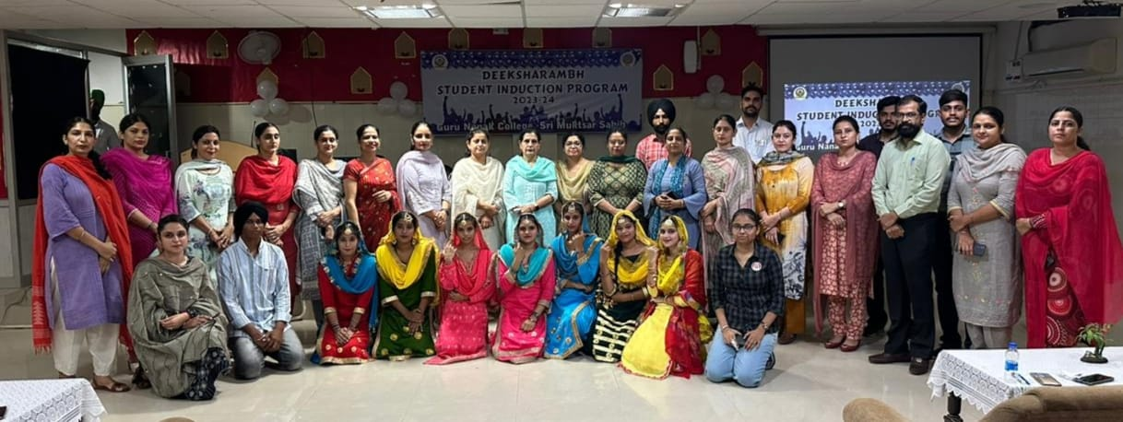
- Celebrated Teachers Day on 5-9-22.

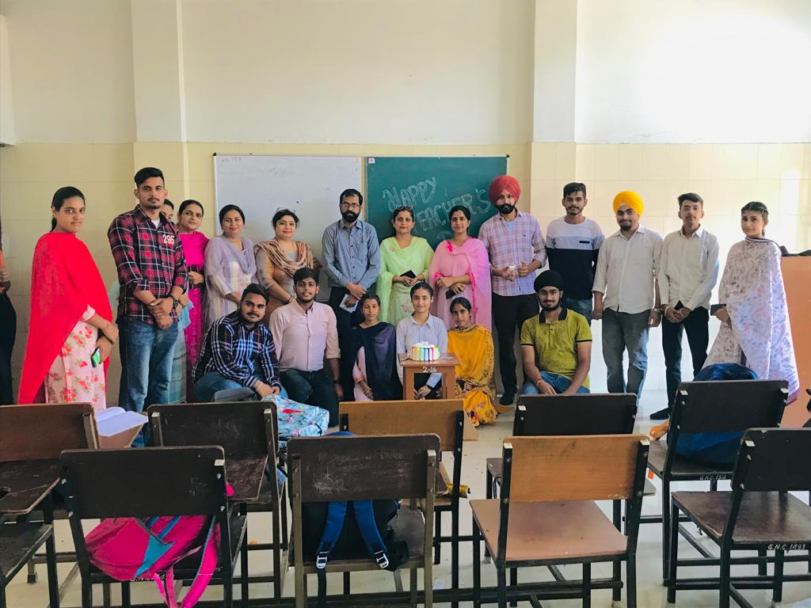

- Interaction Session by officials from the NIIT regarding their Career Opportunities especially in Banks 15-11-2022

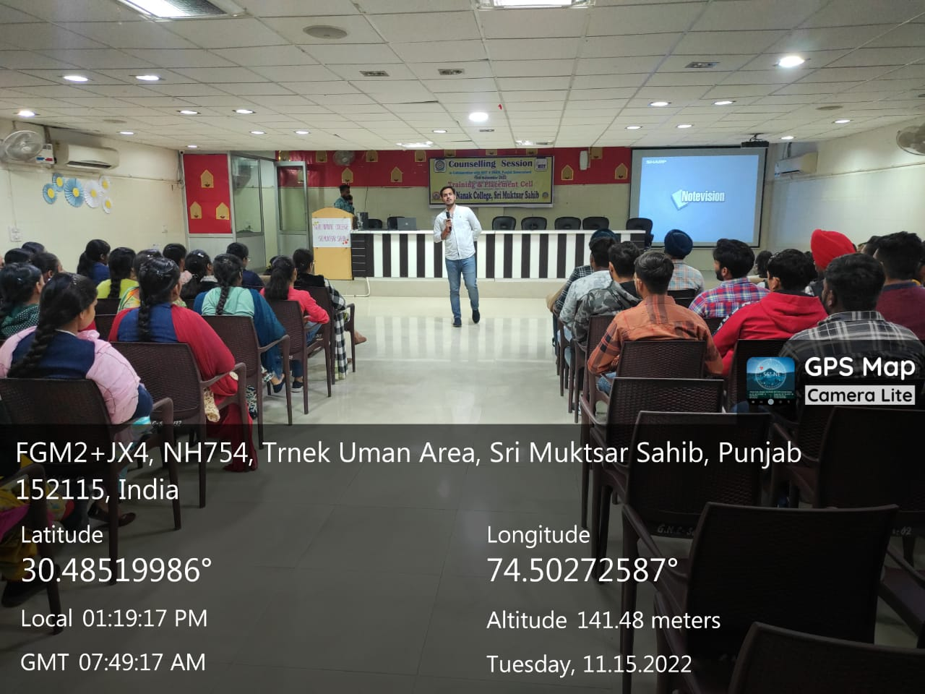

- Students of School of Excellence, Scheme of Panjab Govt visited Department and Punjab govt covered it on the Facebook page with our prominent Institute on 24-5-2023.
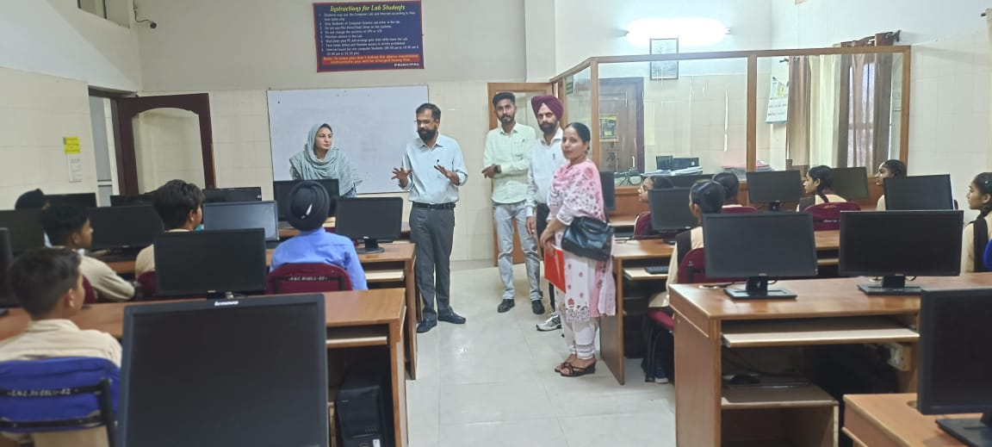
- Placement Drive by ICICI on 23-3-2023.

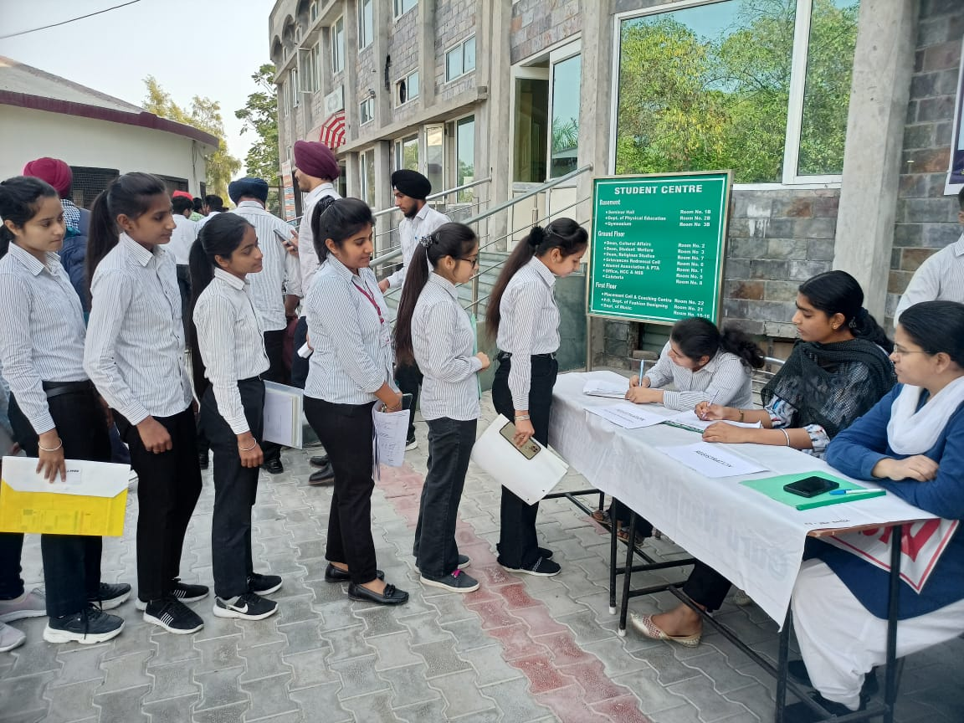
- Organized live interaction with chief Election Commission in Concern to Aware about their Voting Rights on 3 Feb. 2023.

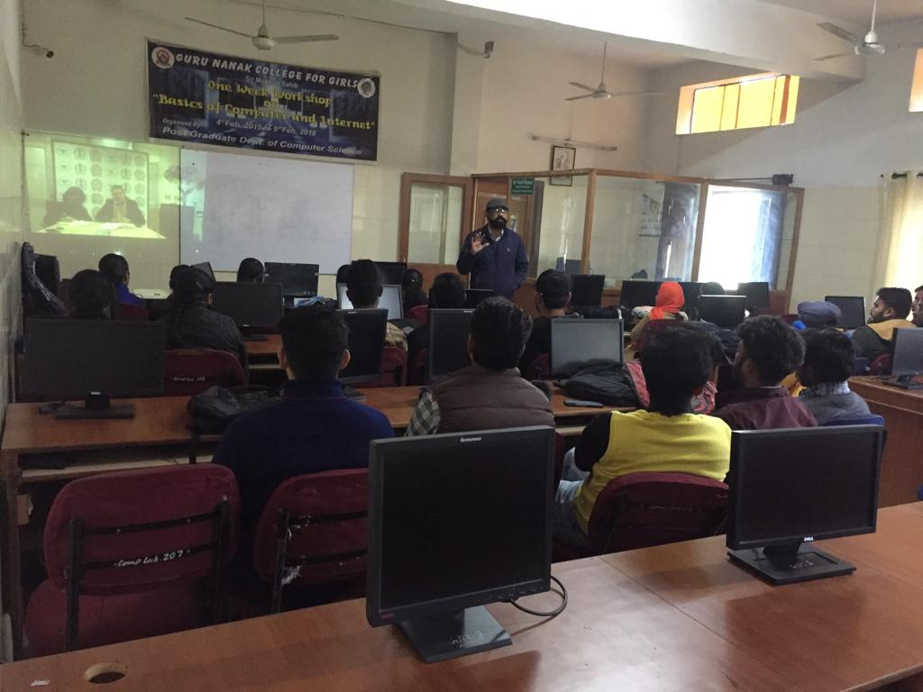

- Oath taking activity in concern to awareness for their voting rights on 25 Jan 2023.
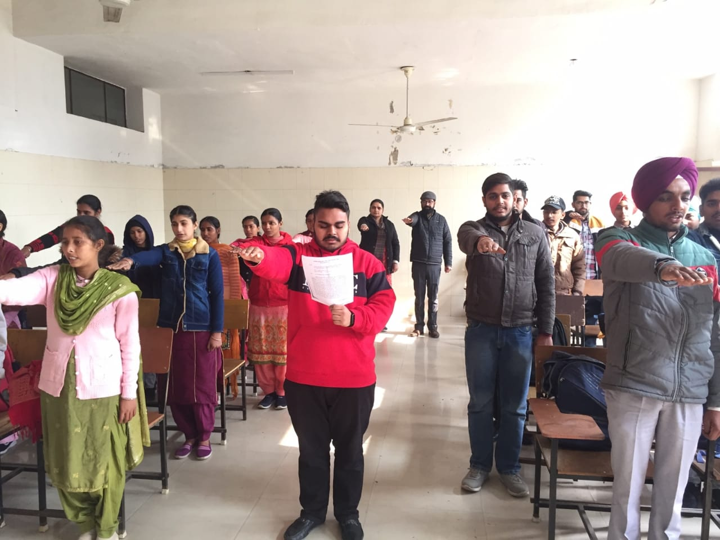

- Organized Farewell Party on 19-4-2023.
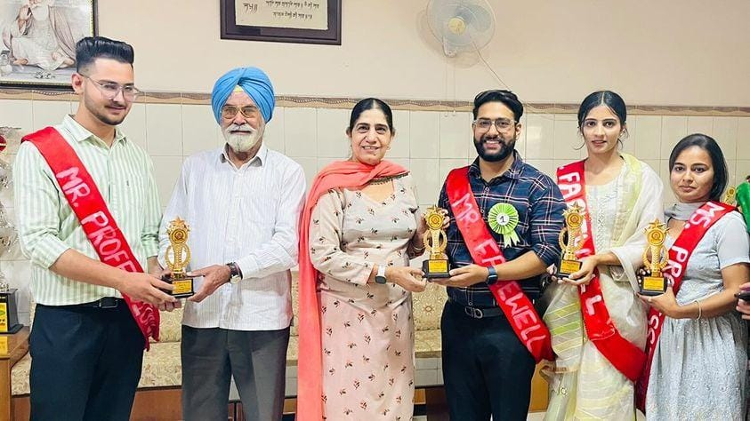

Best Practices 2022-23

SWOC Analysis 2022-23

Student Achievements 2022-23

